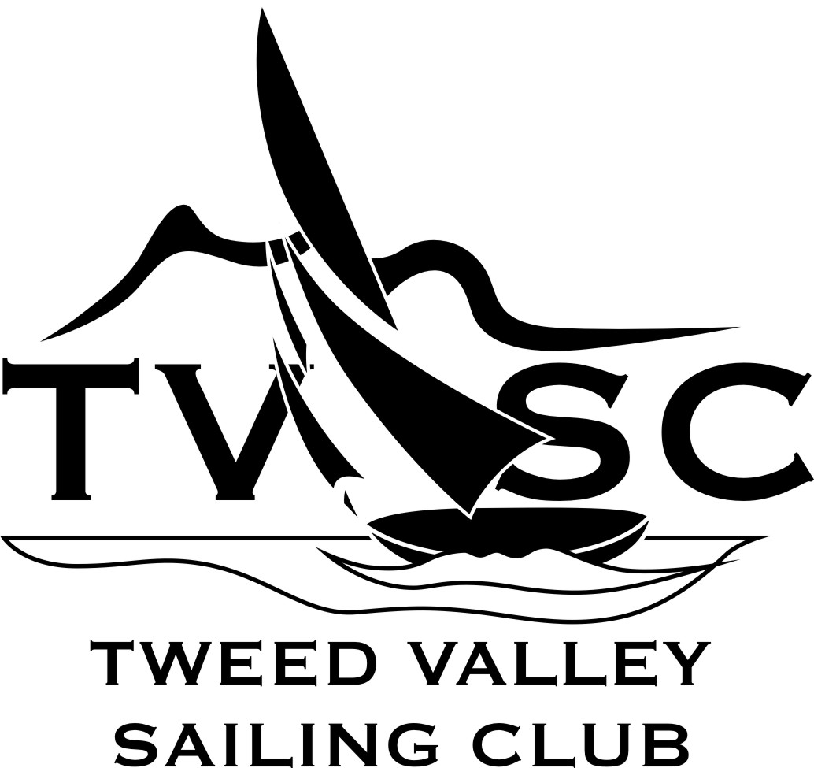 | TWEED VALLEY SAILING CLUB  INDEMNITY FORM for Non-Members  Tweed Valley Sailing Club - Incorporated Association 9895105 c/o 39 Clareville Road, Smiths Creek NSW 2484

NAME: I hereby release the Tweed Valley Sailing Club Inc. and all club officials and committee members and/or representatives thereof, from any claim or demand that I/we may have or deem to have on my/our behalf arising out of participation in any Tweed Valley Sailing Club event and indemnify the Tweed Valley Sailing Club Inc. and all club officials and committee members and/or representatives thereof, against any claim that may be made.

Signature of participant / parent or guardian: Date: / / .

Phone:_______________________Email:_____________________________________

Suburb__________________________ Emergency Contact___________________________________________

--------------------------------------------------------------------------------------------------------------------------
 PLEASE READ AND KEEP THIS SECTION

REDUCING RISK : You can help reduce risk to yourself and any minors whom you supervise by following these guidelines:

- Always wear a life jacket and adequate sun protection and carry water while sailing.
- Always wear footwear while sailing – especially on the Fingal boat ramp.
- Always examine the sand or grass you intend to walk on and look out for sharp objects.
- Always check the weather forecast before going sailing. As skipper of your boat you are responsible for the decision as to whether to sail or continue sailing and for ensuring the people on your boat are competent for the conditions.
- Wear warm clothes (wool layers) + a windproof jacket in cold or windy weather.
- Beware of flapping sails and swinging booms while sailing and on land.
- Attend the briefing at the start of any TVSC event.

RISK WARNING – TVSC
This RISK WARNING is issued jointly by the Tweed Valley Sailing Club (TVSC) and the Waterways Authority (trading
as NSW Maritime) pursuant to the Civil Liability Act 2002 to all persons wishing to participate in the sailing activities conducted by
TVSC.

Participants are warned that, regardless of the precautions, which might be taken by reasonable and experienced persons, sailing can
be a dangerous pursuit and participants are exposed to significant risk of property damage, physical harm and possibly death.
River sailing also has an increased risk.

As an indication, these risks may include, but are not limited to:
• The extremes of weather and sea conditions.
• The potential that control of a vessel may be lost, resulting in collision between vessels or with objects.
• The potential that the vessel will run aground or hit a floating object, especially after heavy rain.
• The sudden movement of the vessel at any time and the possibility of capsizes or that participants may fall or be thrown overboard, resulting in drowning.
• The possibility that participants may be injured by equipment on the vessel, which may include being hit by a boom, sail or rope swinging or flapping in the wind either ashore of afloat.
• The absence of immediate medical care and the likelihood that significant delays may occur before medical care is available.
• Exposure to the elements for extended periods.
• Sunburn and the possibility of skin cancer from sun exposure to unprotected skin.
• Injury or infection from standing on sharp objects in the sand.
TVSC and NSW Maritime also warn participants that regardless of their best intentions, they may be unable to render assistance to
participants who are in distress. Participants are warned to consider the above risks and all other risks before deciding to participate in
any sailing event with TVSC. Any participant who considers that they have a need for insurance must make their own private arrangements with an insurer.

It is noted that a personal accident insurance policy is available with membership of Yachting NSW (included with TVSC membership).

www.tvsc.com.au Email: tvscmail@gmail.com

